TC-AUTH-016
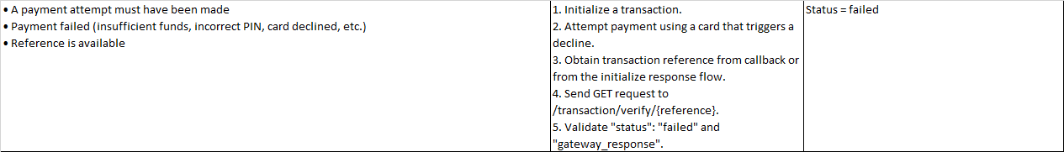
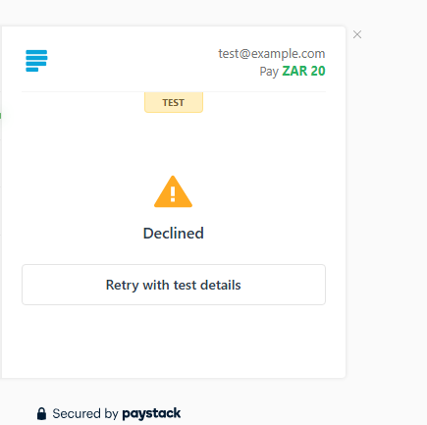
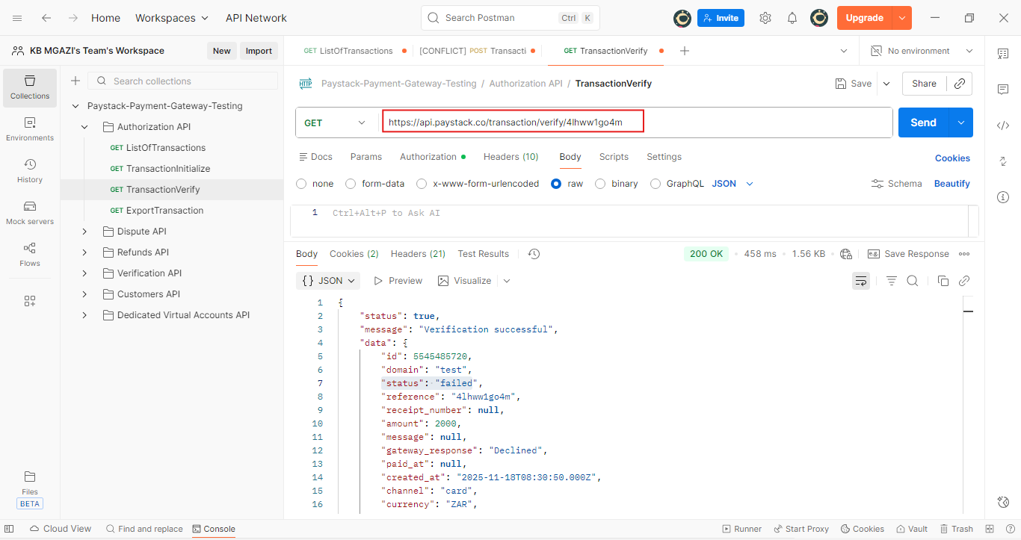

Request:
https://api.paystack.co/transaction/verify/4lhww1go4m

Response:
{
"status": true,
"message": "Verification successful",
"data": {
"id": 5545485720,
"domain": "test",
"status": "failed",
"reference": "4lhww1go4m",
"receipt_number": null,
"amount": 2000,
"message": null,
"gateway_response": "Declined",
"paid_at": null,
"created_at": "2025-11-18T08:30:50.000Z",
"channel": "card",
"currency": "ZAR",
"ip_address": "105.245.32.160",
"metadata": "",
"log": {
"start_time": 1763454662,
"time_spent": 5,
"attempts": 1,
"errors": 1,
"success": false,
"mobile": false,
"input": [],
"history": [
{
"type": "action",
"message": "Attempted to pay with card",
"time": 4
},
{
"type": "error",
"message": "Error: Declined",
"time": 5
}
]
},
"fees": null,
"fees_split": null,
"authorization": {
"authorization_code": "AUTH_9pyqn1tnfv",
"bin": "408408",
"last4": "5408",
"exp_month": "12",
"exp_year": "2030",
"channel": "card",
"card_type": "visa ",
"bank": "TEST BANK",
"country_code": "ZA",
"brand": "visa",
"reusable": true,
"signature": "SIG_cn1Z8ZXJtjJeu2CXe5ei",
"account_name": null
},
"customer": {
"id": 319153466,
"first_name": null,
"last_name": null,
"email": "test@example.com",
"customer_code": "CUS_sl8u4vb80xy24wg",
"phone": null,
"metadata": null,
"risk_action": "default",
"international_format_phone": null
},
"plan": null,
"split": {},
"order_id": null,
"paidAt": null,
"createdAt": "2025-11-18T08:30:50.000Z",
"requested_amount": 2000,
"pos_transaction_data": null,
"source": null,
"fees_breakdown": null,
"connect": null,
"transaction_date": "2025-11-18T08:30:50.000Z",
"plan_object": {},
"subaccount": {}
}
}

